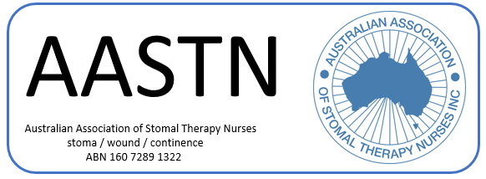

Overseas Travel Grant

Value:

• Six thousand dollars ($6000) every second year on the odd year (subject to financial climate)

Objective:

• To assist an active AASTN Full Member to participate in overseas research, conference or other projects

Closing Date:

• October 31 of alternate years (odd years)

Applying:

• The application form is available on the AASTN website

• A current resume and other supportive documentation as listed on the application form must be submitted to the AASTN Executive Secretary via email [secretary@stomaltherapy.au](mailto:secretary@stomaltherapy.au)

Selection Criteria and Guidelines:

• Applicants must currently be registered with the Australian Health Practitioner Regulation Agency (AHPRA) and utilising their Stomal Therapy expertise

• Applicants must be Full AASTN Members and active within their state or national bodies

• A letter of endorsement from the State Branch must accompany the application form

• A letter of recommendation from the Director of Nursing or Departmental Head supporting the applicant must be forwarded

o This letter should indicate the applicant's commitment to the development of excellence in the field of Stomal Therapy Nursing

o Inclusion of the applicant's job description would be desirable

• The project must be commenced within two (2) years

• Receipt of a grant automatically excludes members from re-applying for five (5) years

• A decision will be available within six (6) weeks

• Executive members may apply for this grant whilst in office

Obligations of the Recipient of the Grant:

• A guarantee by the applicant to continue nursing practice for at least six (6) months after their return is required

o A medical certificate must be supplied to the AASTN Executive if the applicant is unable to fulfil this contract due to illness

• Within three (3) months of their return, the applicant is to submit a report for publication to the AASTN Executive, and acknowledge the support of the AASTN